She Ji: The Journal of Design, Economics, and Innovation

Paper Template for Manuscript

Your Paper Title

Subtitle: If applicable.

Abstract: In this document we describe the formatting requirements for She Ji: The Journal of Design, Economics, and Innovation. Every submission should begin with an abstract of maximum 200 words, followed by 3 to 6 keywords or phrases.

Keywords: Author guide, Chicago Manual of Style, instructions, paper template.

Introduction (Level I Heading)
This document gives formatting instructions for authors preparing papers for publication in She Ji: The Journal of Design, Economics, and Innovation (She Ji). Therefore, we ask that authors follow some simple guidelines. You can use this document as both an instruction set and as a template into which you can type your own text.

Required Submission Files
A Submission should include: 1) Microsoft Word ONLY, 1.5-line-spaced typed manuscript, containing 6,000–8,000 words (excluding footnotes, references, and captions), and images and tables imbedded within text and appropriately placed; 2) One title page including, for each author named: current affiliations, email addresses, and if desired, reference to publications; 3) For each author, we request a brief biographical statement of 50–100 words plus author email; biographies will be published on the Contributor’s Page for authors of accepted submissions;4) high resolution images must be uploaded through the submission system in addition to manuscripts; and 5) Supporting multimedia files, if any, must be submitted in required formats: MPEG and Quicktime.

Authors are required to obtain and provide permissions to reprint any images, etc., for which they do not hold rights. Authors must obtain permissions before publication.

Page Format

Page layout (Level II heading)
Authors must use a page size corresponding to A4 which is 210mm (8.27”) wide and 297mm (11.69”) long. The margins must be set as follows:
- Top = 30mm
- Bottom = 20mm
- Left = Right = 25mm
Right margins need not be justified. Beware, especially when using this template on a Macintosh, Word can change these dimensions in unexpected ways.

Page style

Text font of entire document (Level III heading)
Please use a 10-point Times New Roman font or, if this is unavailable, another proportional font with serifs, as close as possible in appearance to Times New Roman 10-point. The Press 10-point font available to users of Script is a good substitute for Times New Roman. If Times New Roman is not available, try the font named Computer Modern Roman. Please use sans-serif or non-proportional fonts only for special purposes, such as headings or source code text.

Author details
Author details must not show academic titles (e.g., Professor), professional titles (e.g., Managing Director), degrees (e.g., Dr.) or membership or fellowship in organizations (e.g., Senior Member IEEE, FDRS). To avoid confusion, the family name must be written as the last part of each author name (e.g. John A.K. Smith). Each affiliation must include the name of the author’s university, organization, or company, the name of the city, and the name of the country where the author is based (e.g., University of California at San Diego, United States of America; Central Academy of Fine Art, Beijing, China; Causal Productions Pty Ltd, Sydney, Australia). Email address is required for the corresponding author. Please remove information about author names and affiliations in this manuscript for the double-blind review process.

Figures and tables
All figures should be cited in the text and numbered consecutively with Arabic numerals. Figures should be placed within the text at the appropriate points, rather than at the end. Authors are responsible for obtaining permission for the reproduction of all illustrations, graphics, or photos for which they do not hold the rights. Each caption must contain a brief description of the image including a rights-holder credit line, as demonstrated in Figures 1 and 2.

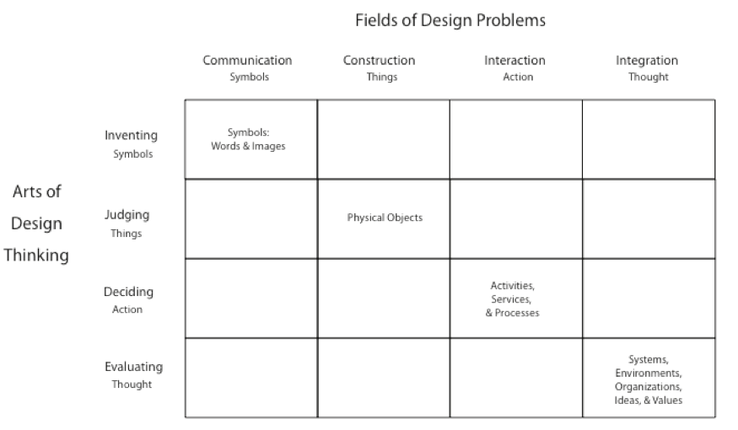
Figure 1. Four Orders of Design. Copyright © 2008 Richard Buchanan.

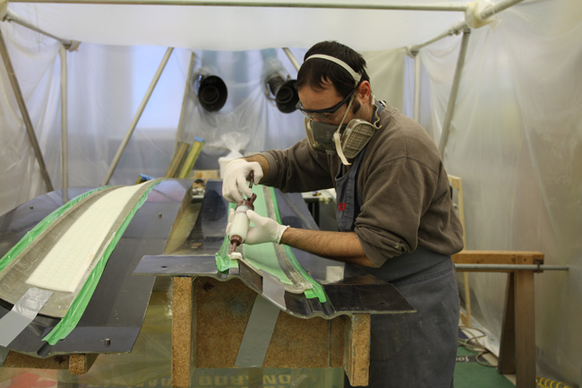
Figure 2. Education through practice: preparation of a mould. Copyright © 2015 Author Name.

Please submit tables as editable text and not as images. All tables should be cited in the text; placed within the text at the appropriate points, rather than at the end; and numbered consecutively with Arabic numerals. Place any table notes below the table body.

Table 1. The rotated component matrix by using extraction method of principal component analysis (PCA) and rotation method of Varimax with Kaiser Normalization
Group | Word Pairs | Componentª
 |  | 1 | 2 | 3 | 4
Experience | Restricting – Expressive | .740
 | Serious – Playful | .707
 | Technical – Human | .659
 | Rigid – Flexible | .657 |  | .403
 | Takes me apart – Brings me closer | .611
 | Unresponsive – Responsive | .583
 | Gaudy – Classy | .439 |  |  | .427
Usability^{b} | Confusing – Clear |  | .744
 | Complicated – Simple |  | .700
 | Cumbersome – Direct |  | .645
 | Unpresentable – Presentable |  | .622
 | Unpredictable – Predictable |  | .481
Novelty | Conservative – Innovative |  |  | .766
 | Typical – Original |  |  | .733
 | Standard – Creative |  |  | .586
 | Commonplace – New |  |  | .573
Others^{c} | Solitary – Collaborative |  |  |  | .671
 | Cautious – Courageous |  |  |  | -.527
 | Delayed – Instant | .431 |  |  | .507
 | Impractical – Practical |  | .421 |  | -.472
a 1, 2, 3, 4 quality groups.
b Significant differences at α=0.05.
c Includes the qualities emerged over the user study instead of determined by the framework.

Direct Quotations
For material quoted directly, incorporate the quotation into the text and enclose it with double quotation marks, such as: Ezio Manzini points out, “if … philosophers can help to study the emergent qualities and define their critical character in more detail, designers should take up their role in picturing this new paradigm.”

All direct quotations must be placed within quotation marks.

Indirect Quotations
Indirect quotations include paraphrases, restatements, and summaries of material from an external source. Best practice now treats indirect quotations in the same manner as direct quotations. The American Psychological Association Publication Manual recommends: “When paraphrasing or referring to an idea contained in another work, [authors] are encouraged to provide a page or paragraph number, especially when it would help an interested reader locate the relevant passage in a long or complex text.” She Ji requests precise, fine-grained references that permit the reader to locate quoted material at the exact location in the source document. Most research articles refer to source documents that total between 3,000 and 6,000 pages. Since half or more of all references involve paraphrase and indirect quotations, an article with imprecise citations requires readers to search thousands of pages of source text to locate cited material – a particularly difficult task for summary or paraphrase. Authors should treat direct quotations, indirect quotations, and paraphrases the same way, with precise references for all quotations and cited sources. This helps the reader while building and supporting the knowledge of the field.

Manuscript Text Format
Manuscripts should conform to The Chicago Manual of Style, 16th edition. Pages should be numbered consecutively.

Footnotes
Footnotes should be numbered consecutively, and references to them indicated by corresponding numbers in the text, as shown in Footnote 1. Style should conform to CMS footnote style. Quotations from foreign language sources should be translated into English in the text; if necessary the original-language quotation may appear in footnotes.

Reference List
The reference list should include only works cited in the text that have been published or accepted for publication. Unpublished results and personal communications should not appear in the reference list, but should be cited in the text as footnotes. The reference list should follow an alphabetic order.

Examples of notes and references
The following examples illustrate citations using the notes and the reference list system. For each citation, both the footnote format and the reference format are provided. Please note the difference between the two. Pay attention to the use of italics, semi-colons, colons, en dashes, word capitalization, and truncated page range. For more details and many more examples, see chapter 14 of The Chicago Manual of Style.

- Book: Authored book
1. Herbert A. Simon, The Sciences of the Artificial, 3rd ed. (Cambridge, Mass.: MIT Press, 1996), 99–100.
2. William McDonough and Michael Braungart, Cradle to Cradle: Remaking the Way We Make Things (New York: North Point Press, 2002), 24.

Simon, Herbert A. The Sciences of the Artificial, 3rd ed. Cambridge, Mass.: MIT Press, 1996.
McDonough, William, and Michael Braungart. Cradle to Cradle: Remaking the Way We Make Things. New York: North Point Press, 2002.

- Book: Edited book
1.Richard Buchanan and Victor Margolin, eds., Discovering Design: Explorations in Design Studies (Chicago: Chicago University Press, 1995), 23.
2. Gerald Bast, Elias G. Carayannis, and David F.J. Campbell, eds., Arts, Research, Innovation and Society (Cham: Springer, 2015), 211.

Buchanan, Richard, and Victor Margolin, eds. Discovering Design: Explorations in Design Studies. Chicago: Chicago University Press, 1995.
Bast, Gerald, Elias G. Carayannis, and David F.J. Campbell, eds. Arts, Research, Innovation and Society. Cham: Springer, 2015.

- Book: English translation
1. Maurice Merleau-Ponty, Phenomenology of Perception, trans. Colin Smith (London: Routledge & Kegan Paul, 1962), 42.

Merleau-Ponty, Maurice. Phenomenology of Perception. Translated by Colin Smith. London: Routledge & Kegan Paul, 1962.

- Book: Electronic book
1. Joyce Yee, Emma Jefferies, and Lauren Tan, Design Transitions (Amsterdam, BIS Publishers, 2013), Kindle Edition.

Yee, Joyce, Emma Jefferies, and Lauren Tan. Design Transitions. Amsterdam, BIS Publishers, 2013. Kindle Edition.

- Chapter or article in an edited book
1. Yongqi Lou, “She Ji: Change for Sustainable Futures,” in The Hand Book of Design for Sustainability, ed. Stuart Walker and Jacques Giard (London: Bloomsbury Academic, 2013), 347.

Lou, Yongqi. “She Ji: Change for Sustainable Futures.” In The Hand Book of Design for Sustainability, edited by Stuart Walker and Jacques Giard, 346–62. London: Bloomsbury Academic, 2013.

- Journal article: One author
1. Richard Buchanan, “Wicked Problems in Design Thinking,” Design Issues 8, no. 2 (Spring 1992): 5.

Buchanan, Richard. “Wicked Problems in Design Thinking.” Design Issues 8, no. 2 (Spring 1992): 5–21.

- Journal article: Two or three authors
1. Adrian Snodgrass and Richard Coyne, “Models, Metaphors and the Hermeneutics of Designing,” Design Issues 9, no. 1 (1992): 56.

Snodgrass, Adrian, and Richard Coyne. “Models, Metaphors and the Hermeneutics of Designing.” Design Issues 9, no. 1 (1992): 56–74.

- Journal article: Four or more authors
1. Chunlei Chai et al., “Behavioral Analysis of Analogical Reasoning in Design: Difference among Designers with Different Expertise Levels,” Design Studies 37, no.1 (2015): 30.

Chai, Chunlei, Fei Cen, Weiyu Ruan, Cheng Yang, and Hongting Li. “Behavioral Analysis of Analogical Reasoning in Design: Difference among Designers with Different Expertise Levels.” Design Studies 37, no.1 (2015): 3–30.

- Article in an online journal
1. Doris Bergen, “The Role of Pretend Play in Children’s Cognitive Development,” Early Childhood Research & Practice, 4, no.1 (Spring 2000), accessed December 1, 2014, http://ecrp.uiuc.edu/v4n1/bergen.html .

Bergen, Doris. “The Role of Pretend Play in Children’s Cognitive Development.” Early Childhood Research & Practice 4, no.1 (Spring 2000). Accessed December 1, 2014. http://ecrp.uiuc.edu/v4n1/bergen.html .

- Non-English journal article
1. Guanzhong Liu and Lingtao Tang, “创新的悖论——‘制造型工业经济’的文化现象 [Paradox of Innovation—The Cultural Phenomenon of ‘Industrial Economy of Manufacturing Type’],” 装饰, no. 12 (2007): 12.

Liu, Guanzhong, and Lingtao Tang. “创新的悖论——‘制造型工业经济’的文化现象 [Paradox of Innovation—The Cultural Phenomenon of ‘Manufacturing Type of Industrial Economy’].” 装饰, no. 12 (2007): 12–15.

- Article in a print proceedings
1. Anna Meroni, “Design for Services and Place Development,” in Cumulus Shanghai Conference Proceedings, Tongji University, ed. Yongqi Lou and Xiaocun Zhu (Helsinki: Aalto University Press, 2011), 236.

Meroni, Anna. “Design for Services and Place Development.” In Cumulus Shanghai Conference Proceedings, Tongji University, edited by Yongqi Lou and Xiaocun Zhu, 234–241. Helsinki: Aalto University Press, 2011.

- Article in an electronic proceedings
1. Daniel Fallman, Linda Bogren, and Catharina Henje, “Attract, Inform, and Interact: Working with Product Semantics in an Inclusive Design Project,” in Proceedings of the IASDR 2009 Congress [CD ROM] (Seoul: Korean Society of Design Science), also available at http://www.iasdr2009.org/navigation/byappearance.html .

Fallman, Daniel, Linda Bogren, and Catharina Henje. “Attract, Inform, and Interact: Working with Product Semantics in an Inclusive Design Project.” In Proceedings of the IASDR 2009 Congress [CD ROM]. Seoul: Korean Society of Design Science, 2009. Also available at http://www.iasdr2009.org/navigation/byappearance.html .

- Article in print magazine or newspaper
1. John Heskett, “Waiting for a new design,” Form 185, September/October, 2002, 92.
2. Mike Royko, “Next Time, Dan, Take Aim at Arnold,” Chicago Tribune, September 23, 1992.

Heskett, John. “Waiting for a new design.” Form 185, September/October, 2002, 92–98.
Mike Royko. “Next Time, Dan, Take Aim at Arnold.” Chicago Tribune, September 23, 1992.

- Article in the online magazine or newsletter
1. Ken Friedman, “Science: What Would Leonardo Study After Year 12?” The Melbourne Review, September 2012, accessed December 1, 2014, http://www.melbournereview.com.au/read/613 .
2. Sheryl Gay Stolberg and Robert Pear, “Wary Centrists Posing Challenge in Health Care Vote,” New York Times, February 27, 2010, accessed February 28, 2010, http://www.nytimes.com/2010/02/28/us/politics/28health.html .

Friedman, Ken. “Science: What Would Leonardo Study After Year 12?” The Melbourne Review, September 2012. Accessed December 1, 2014. http://www.melbournereview.com.au/read/613 .
Stolberg, Sheryl Gay, and Robert Pear. “Wary Centrists Posing Challenge in Health Care Vote.” New York Times, February 27, 2010. Accessed February 28, 2010. http://www.nytimes.com/2010/02/28/us/politics/28health.html .

- Published thesis or dissertation
1. Kees Dorst, Describing Design: A Comparison of Paradigms (Delft, the Netherlands: Delft University of Technology, 1997), 123.

Dorst, Kees. Describing Design: A Comparison of Paradigms. Delft, the Netherlands: Delft University of Technology, 1997.

- Unpublished or informally published materials
1. Patricia Burns, e-mail message to author, December 15, 2008.
2. Cory Cotter, “The Weakest Link: The Argument for On-Wrist Band Welding” (unpublished manuscript, last modified December 3, 2008), Microsoft Word file.

Only use footnote. Do not enter in reference list.

- Website
1. “Google Privacy Policy,” last modified March 11, 2009, http://www.google.com/intl/en/privacypolicy.html .

Google. “Google Privacy Policy.” Last modified March 11, 2009. http://www.google.com/intl/en/privacypolicy.html .

- Web page with known author and date
1. Jungah Lee, “Samsung Boosts Dividend as Profit Beats Estimates on Chips,” Bloomsberg.com, last modified January 29, 2015,
http://www.bloomberg.com/news/articles/2015-01-28/samsung-boosts-dividend-as-profit-beats-estimates-on-chips .
2. Don Norman, “Why Design Education Must Change,” Core77, last modified November 26, 2010, http://www.core77.com/blog/columns/why_design_education_must_change_17993.asp .

Lee, Jungah. “Samsung Boosts Dividend as Profit Beats Estimates on Chips.” Bloomsberg.com. Last modified January 29, 2015.
http://www.bloomberg.com/news/articles/2015-01-28/samsung-boosts-dividend-as-profit-beats-estimates-on-chips .
Norman, Don. “Why Design Education Must Change.” Core77. Last modified November 26, 2010, http://www.core77.com/blog/columns/why_design_education_must_change_17993.asp .

- Blog
1. Amy Frearson, “Reconstruction of Nahr el-Bared Refugee Camp,” Dezeen (blog), May 2, 2013 (7:49 p.m.), http://www.dezeen.com/2013/05/02/reconstruction-of-nahr-el-bared-refugee-camp .

Frearson, Amy. “Reconstruction of Nahr el-Bared Refugee Camp.” Dezeen (blog), May 2, 2013 (7:49 p.m.). http://www.dezeen.com/2013/05/02/reconstruction-of-nahr-el-bared-refugee-camp .

- Online multimedia
1. “Hans Rosling’s 200 Countries, 200 Years,” YouTube video, 4:42, from The Joy of Stats: Documentary Film by BBC Four on December 7, 2010, posted by BBC, November 26, 2010, http://www.youtube.com/watch?v=jbkSRLYSojo .

“Hans Rosling’s 200 Countries, 200 Years.” YouTube video, 4:42, from The Joy of Stats: Documentary Film by BBC Four on December 7, 2010. Posted by BBC, November 26, 2010. http://www.youtube.com/watch?v=jbkSRLYSojo .

- Film, Television, and other recorded mediums
1. Objectified, directed by Gary Hustwit (2009; Brooklyn, NY: Plexifilm, 2010), DVD.

Objectified. Directed by Gary Hustwit. 2009. Brooklyn, NY: Plexifilm, 2010. DVD.

- Report
1. World Commission on Environment and Development, Report of World Commission on Environment and Development: Our Common Future, transmitted to the General Assembly as an Annex to Document A/42/427- Development and International Co-operation: Environment (United Nations, 1987), accessed December 3, 2014, http://www.un-documents.net/wced-ocf.htm .

World Commission on Environment and Development. Report of World Commission on Environment and Development: Our Common Future, transmitted to the General Assembly as an Annex to Document A/42/427- Development and International Co-operation: Environment. United Nations, 1987. Accessed December 3, 2014. http://www.un-documents.net/wced-ocf.htm .

- Exhibition catalog
1. Utopia: Matters: From Brotherhoods to Bauhaus, ed. Vivien Greene (New York: Guggenheim Museum, 2010), exhibition catalog.

Utopia: Matters: From Brotherhoods to Bauhaus. Edited by Vivien Greene. New York: Guggenheim Museum, 2010. Exhibition catalog.

Conclusions
In comparison with other journal reference styles, CMS footnote style is less common. Readers welcome it because it enhances the reading experience. Please see the journal Design Issues to see examples of CMS footnotes and the conventions that successful authors use. A fluent reading experience is important for a journal to that appeals to a broad audience including researchers, teachers, and students, as well as professional practitioners, and leaders in business and industry. She Ji developed author guidelines and article templates to achieve this goal.

Acknowledgments
Authors should collate acknowledgements in a separate section at the end of the article. Place acknowledgements before the references. Do not include them on the title page, in footnotes, or otherwise. Acknowledgements should list individuals who provide help in research such as suggestions on methods and methodology, calculations and statistics, resources and tools. Acknowledgements should also list those who provide help in writing the article, such as language help, writing assistance, or proof reading. It is also appropriate to acknowledge those who provide broader help by reading the article to offer suggestions.

References
Use a list of references at the end of the article, ordered alphabetically by first author.

Examples of References
Bast, Gerald, Elias G. Carayannis, and David F.J. Campbell, eds. Arts, Research, Innovation and Society. Cham: Springer, 2015.
Buchanan, Richard. “Wicked Problems in Design Thinking.” Design Issues 8, no. 2 (Spring 1992): 5–21.
Friedman, Ken. “Science: What Would Leonardo Study After Year 12?” The Melbourne Review, September 2012. Accessed December 1, 2014. http://www.melbournereview.com.au/read/613 .
“Hans Rosling’s 200 Countries, 200 Years.” YouTube video, 4:42, from The Joy of Stats: Documentary Film by BBC Four on December 7, 2010. Posted by BBC, November 26, 2010. http://www.youtube.com/watch?v=jbkSRLYSojo .
Manzini, Ezio, and Virginia Tassinari. “Sustainable Qualities: Powerful Drivers of Social Change.” In Emerging Practices. Professions, Values, and Approaches in Design, edited by Jin Ma and Yongqi Lou, 160–95. Beijing: China Architecture and Building Press, 2014.
McDonough, William, and Michael Braungart. Cradle to Cradle: Remaking the Way We Make Things. New York: North Point Press, 2002.
Meroni, Anna. “Design for Services and Place Development.” In Cumulus Shanghai Conference Proceedings, Tongji University, edited by Yongqi Lou and Xiaocun Zhu, 234–241. Helsinki: Aalto University Press, 2011.
Norman, Don. “Why Design Education Must Change.” Core77. Last modified November 26, 2010, http://www.core77.com/blog/columns/why_design_education_must_change_17993.asp .
Objectified. Directed by Gary Hustwit. 2009. Brooklyn, NY: Plexifilm, 2010. DVD.
Stolberg, Sheryl Gay, and Robert Pear. “Wary Centrists Posing Challenge in Health Care Vote.” New York Times, February 27, 2010. Accessed February 28, 2010. http://www.nytimes.com/2010/02/28/us/politics/28health.html .
The Chicago Manual of Style, 16th ed, (Chicago and London: The University of Chicago Press, 2010), also available at www.chicagomanualofstyle.org/tools_citationguide.html .
Utopia: Matters: From Brotherhoods to Bauhaus. Edited by Vivien Greene. New York: Guggenheim Museum, 2010. Exhibition catalog.
World Commission on Environment and Development. Report of World Commission on Environment and Development: Our Common Future, transmitted to the General Assembly as an Annex to Document A/42/427- Development and International Co-operation: Environment. United Nations, 1987. Accessed December 3, 2014. http://www.un-documents.net/wced-ocf.htm .

Appendix(es)
If an article contains more than one appendix, appendices should be identified as A, B, etc. Formulae and equations in appendices should be given separate numbers: Eq. (A.1), Eq. (A.2), etc. Each appendix should start a new numbering squequence: Eq. (B.1) and so on. Authors should follow the same procedure for tables and figures: Table A.1; Fig. A.1, etc.
Authors should present additional data such as questionnaires at the end of the manuscript. Authors who wish to exhibit video showcases should first upload the video file to youtube.com or another online service. For these, authors should provide the screenshot, title, URL, and descriptions as shown here:
Table 2. Sample table for supporting multimedia materials.
Video screenshot | Title and link
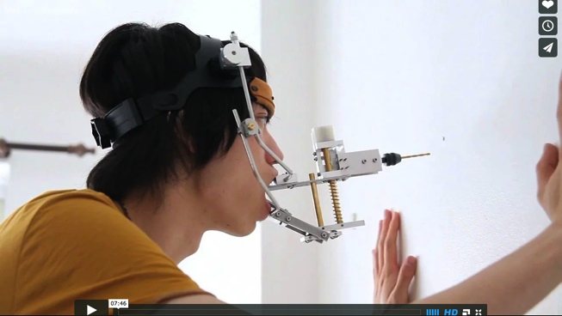 | Mouth Factory  URL: http://vimeo.com/44281343  (This video is not elaborated in this study, but it may serve as a nice example to understand alternative possibilities of the concept of human enhancement, which aims to explore the aesthetic of production through a series of performative devices.)
We encourage authors to submit multimedia files that are essential to the conclusions of the article. She Ji will publish multimedia files, such as 3-dimensional computer models, videos, and interactive demonstrations, as online addenda to the manuscript. The preferred formats are MPEG and Quicktime.

Ezio Manzini and Virginia Tassinari, “Sustainable Qualities: Powerful Drivers of Social Change,” in Emerging Practices. Professions, Values, and Approaches in Design, ed. Jin Ma and Yongqi Lou (Beijing: China Architecture and Building Press, 2014), 194.
American Psychological Association, Publication Manual of the American Psychological Association, Sixth Edition (Washington, DC: The American Psychological Association, 2010), 171.
The Chicago Manual of Style, 16th ed. (Chicago and London: The University of Chicago Press, 2010), also available at www.chicagomanualofstyle.org/tools_citationguide.html .

